Team Shop Login

Create an Account
- To create your account, click here https://www.cuore.ch/teamshop/us/login.php
- Click Next under New Customer
- Enter your customer information – if your ship address is different than your billing, please enter your billing address and then email us with your ship address at info_us@cuore.ch
- Copy and paste your Team Shop Login BlueRidge as show below
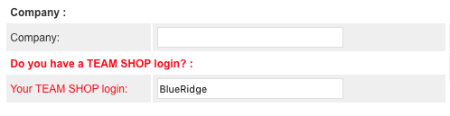
- Check the privacy policy box and click to create your free account as shown below
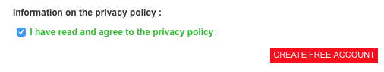

- You will see your Team’s Shop displayed in the upper left corner of your screen, click there to view and order product
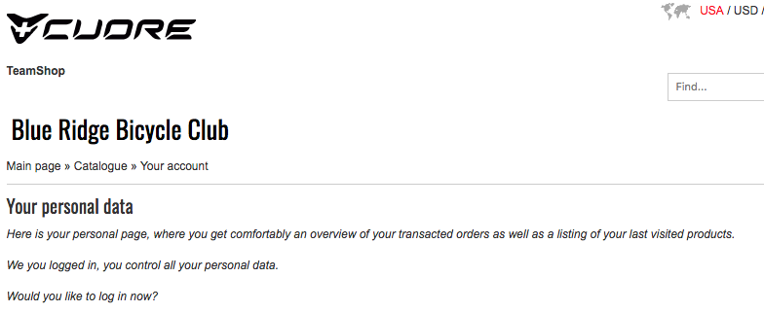

If you have any questions, please email us at info_us@cuore.ch and we’ll be happy to help!

