Team Shop Login

Existing Account
- To login, click here https://www.cuore.ch/teamshop/us/login.php
- Under I am a returning customer, enter your Email and Password
- Click the Yes bubble and the grey Login button
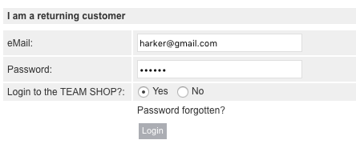
- You will see your Team’s Shop displayed in the upper left corner of your screen, click there to view and order product
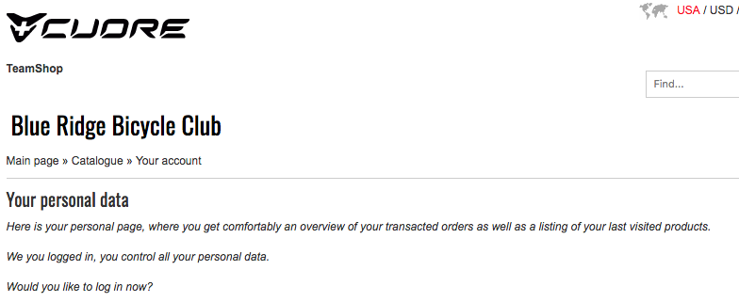

If you have any questions, please email us at info_us@cuore.ch and we’ll be happy to help!

